

23CSE203
DATA STRUCTURES AND ALGORITHM

Submitted by
Name | GOWRNENI MOKSHAGNASAI
Roll.no | AV.SC.U4CSE25111
Section | CSE-B

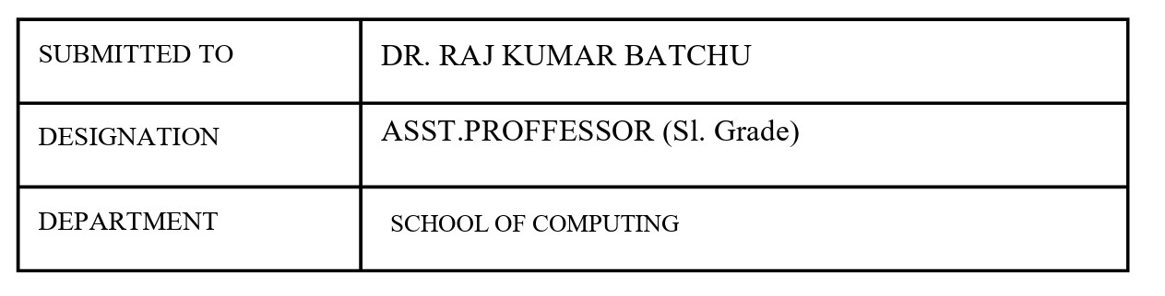
Credit | 5

Index
S.no | Title | Page.no | Remark
1. | - A rocket launch system displays a countdown before launch. Instead of using loop, implement the countdown using recursion. Write a recursive program to display a countdown from n to 1 followed by launch.  - Bank calculates the growth of an investment using compound intrest. The formula requires calculating powers, which can be implemented recursively. Write a recursive program to calculate p^{n}(power), where P=principal growth factor, n=no.of years.  - Write a recursive progrsm to print the first n terms of fibanocci series  - An hr department stores employee ids in a list develop a recursive program to search for a given employee id. Write a recursive function to search for an employee id in the list.  - In a logistics the no.of possible ways to arrange n different parcels calculate using the factorial (n!). develop a recursive program to calculate the factorial of given number. | 5-10
2. | - write a python program to perform linear search on the given input  - Write a python program to perform binary search on the given | 11-13
 | input. Verify by taking sorted array and unsorted array as a list.
3. | A) write a python program to implement bubble sort, where the elements are taken from user. B) write a python program to implement selection sort, where the elements are taken from user. C) write a python program to implement insertion sort, where the elements are taken from user. | 14-17
4. | A) write a python program to implement Merge sort, where the elements are taken from user. B) write a python program to implement Quick sort, where the elements are taken from user. | 18-20
5. | - AIM: Write a program to implement SLL with the below operations. Create linked list, Insert Beginning, Insert End, Insert at Index, delete by value, delete first node, delete last node, count number of nodes, display/transverse exit.  - AIM: Write a program to implement DLL with the below operations. Create linked list, Insert Beginning, Insert End, Insert at Index, delete by value, delete first node, delete last node, count number of nodes, display/transverse exit. | 21-25
6. | - AIM: Write a python program to implement stack operations such as push, pop, peek, display using an array and a linked list. | 26-29
7. | A) Write a python program to implement Queue and its operations such as enqueue ,dequeue, peek, display with a menu driven approach. Implement using array and linked list data structures.  B) Write a python program to implement CircularQueue and its operations such as enqueue , dequeue, peek, display with a menu driven approach. Implement using array and linked list data structures | 30-36
8. | A)AIM: write a python program to implement a binary tree with its operations using a array and a linked list. | 37-39
9. | A)AIM: write a python program to implement a binary search treee with its operation and traversals. | 40-43

Week-1
- Aim: A rocket launch system displays a countdown before launch. Instead of using loop, implement the countdown using recursion. Write a recursive program to display a countdown from n to 1 followed by launch. Program:

Code and Output:
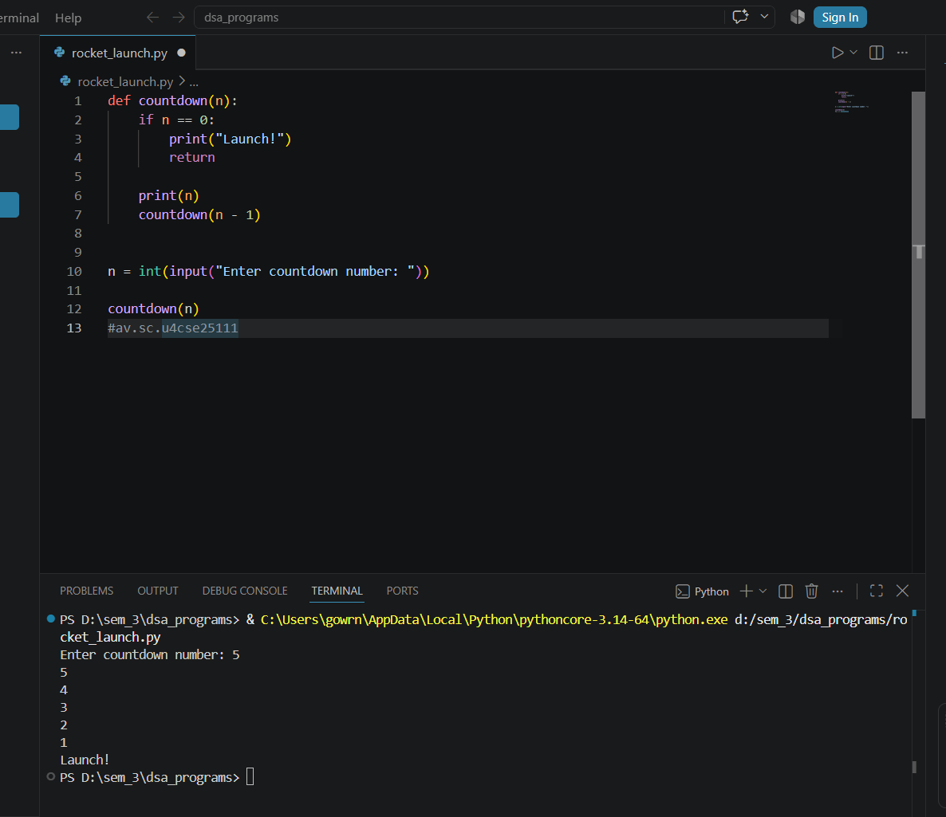

Explanation:
This Python program uses recursion to display a rocket launch countdown from n to 1. The countdown(n) function first checks whether n is 0; if it is, the program prints "Launch!" and stops, which is called the base case. If n is not 0, the program prints the current value of n and calls the same function again using countdown(n - 1), reducing the value by 1 each time. The user enters the starting countdown number using input(), and countdown(n) starts the recursive process. For example, if the user enters 5, the output will be 5, 4, 3, 2, 1, Launch!. Thus, the program performs the countdown using recursion without using any loop.

s.no | Error obtained | Rectification
1. | Infinite loop | Iteration at correct place
2. | Calling function at wrong place | Placed with correct syntax

-----------------------------------------------------------------------------------------------------------------
- Aim: Bank calculates the growth of an investment using compound intrest. The formula requires calculating powers, which can be implemented recursively. Write a recursive program to calculate p^{n}(power), where P=principal growth factor, n=no.of years.
Program and Output:
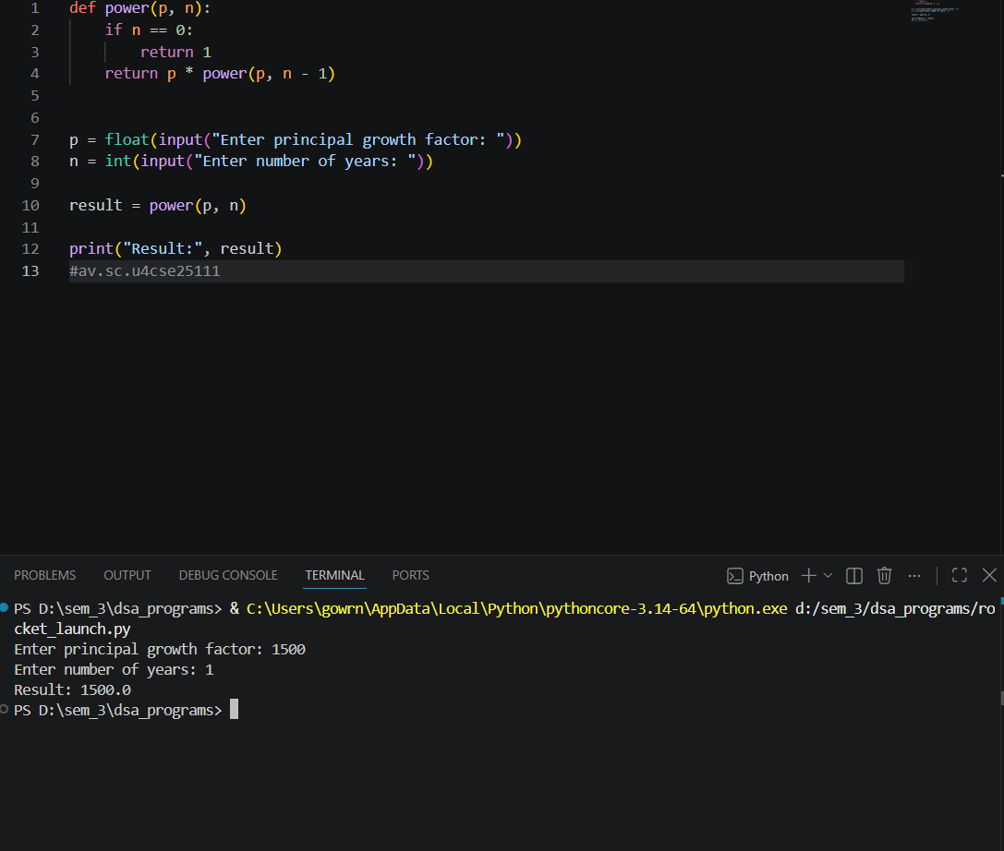

Explanation:
This Python program calculates Pⁿ (P raised to the power n) using recursion. The power(p, n) function checks whether n is 0; if it is, it returns 1, which is the base case. Otherwise, it multiplies p by the result of power(p, n - 1), repeatedly reducing n by 1 until it reaches 0. The user enters the principal growth factor P and the number of years n, and the recursive function calculates Pⁿ. For example, if P = 2 and n = 5, the result is 32. Thus, the program calculates powers using recursion without using a loop.
s.no | Error obtained | Rectification
1. | Return 0 | Return 1
2. | print | return

---------------------------------------------------------------------------------------------------------------------
C)Aim: Write a recursive program to print the first n terms of fibanocci series
Program and Output:
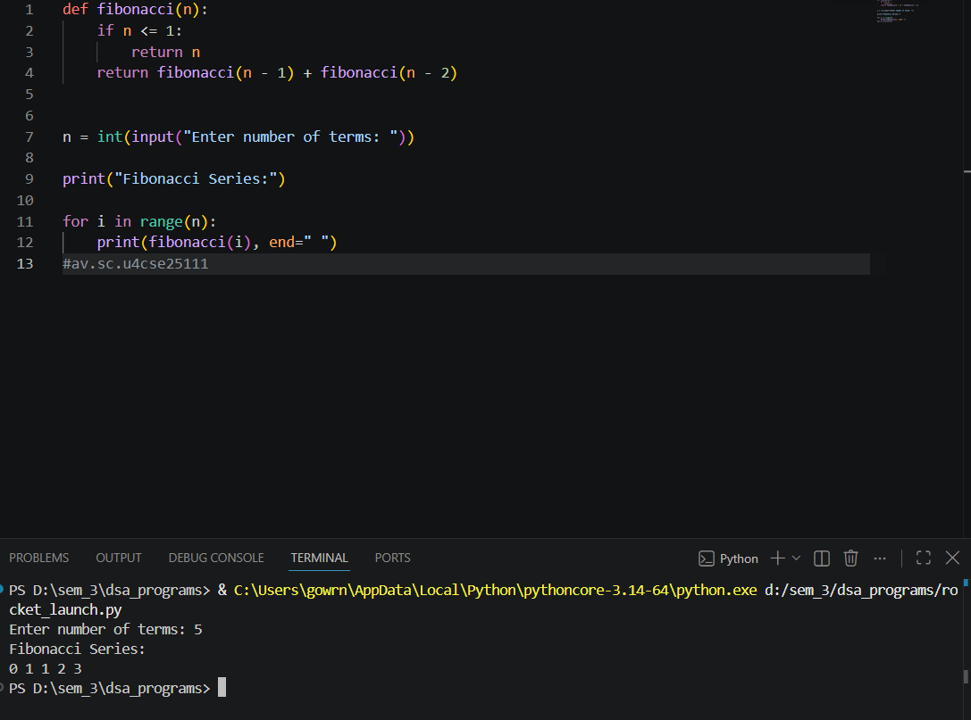
Explanation:
This Python program prints the first n terms of the Fibonacci series using recursion. The fibonacci(n) function checks whether n is 0 or 1; if so, it returns n, which is the base case. Otherwise, it recursively calculates the previous two terms using fibonacci(n - 1) + fibonacci(n - 2). The user enters the number of terms, and the for loop calls the recursive function for each term. For example, if n = 7, the output will be 0 1 1 2 3 5 8.
s.no | Error obtained | Rectification
1. | Forgot to declare n<=1 | rectified
2. | Formula mistake | rectified

----------------------------------------------------------------------------------------------------------------
D)Aim: An hr department stores employee ids in a list develop a recursive program to search for a given employee id. Write a recursive function to search for an employee id in the list.
Program and Output:
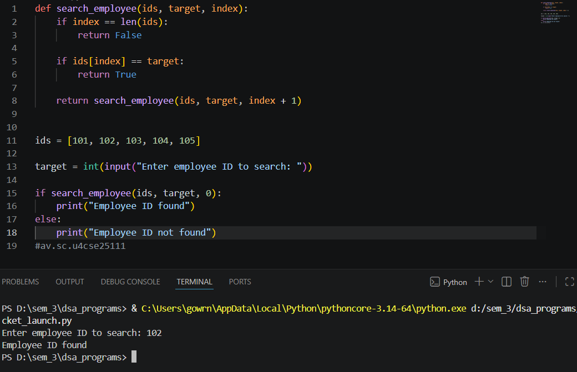

Explanation:
This Python program searches for a given employee ID in a list using recursion. The search_employee() function checks each employee ID starting from the given index. If the index reaches the end of the list, it returns False, which is the base case for an unsuccessful search. If the current employee ID matches the target ID, it returns True. Otherwise, the function calls itself with index + 1 to check the next employee ID. For example, if the target ID is 103, the program searches through the list and displays "Employee ID found". If the ID is not present, it displays "Employee ID not found".
s.no | Error obtained | Rectification
1. | Emplist | Emp_list
2. | print | Return

--------------------------------------------------------------------------------------------------------------

E) Aim: In a logistics the no.of possible ways to arrange n different parcels calculate using the factorial (n!). develop a recursive program to calculate the factorial of given number.
Program and Output:
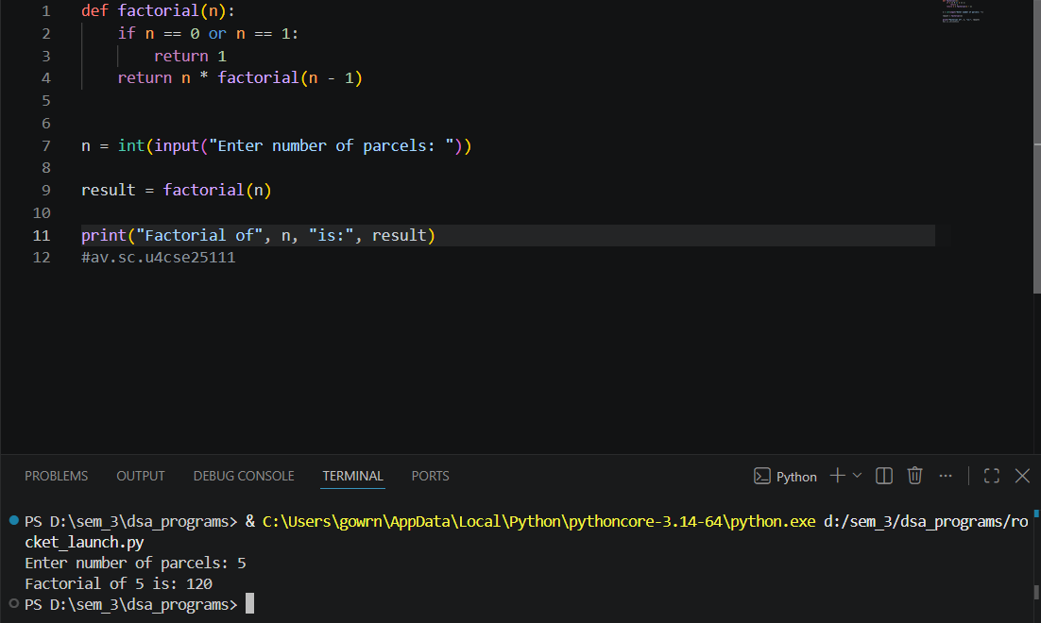

Explanation:
This Python program calculates the factorial of a given number using recursion.
The factorial(n) function checks whether n is 0 or 1; if so, it returns 1, which is the base case. Otherwise, it multiplies n by factorial(n - 1), and the function continues calling itself until it reaches 1. The user enters the number of parcels, and the recursive function calculates the number of possible arrangements using n!. For example, if n = 5, the calculation is 5 × 4 × 3 × 2 × 1 = 120, so the output is "Factorial of 5 is: 120".

s.no | Error obtained | Rectification
1. | n+1 | n-1
2. | Syntax error | Rectifie

--------------------------------------------------------------------------------------------------------------

WEEK-2
A) AIM: Write a python program to perform linear search on the given input.
Program and Output:
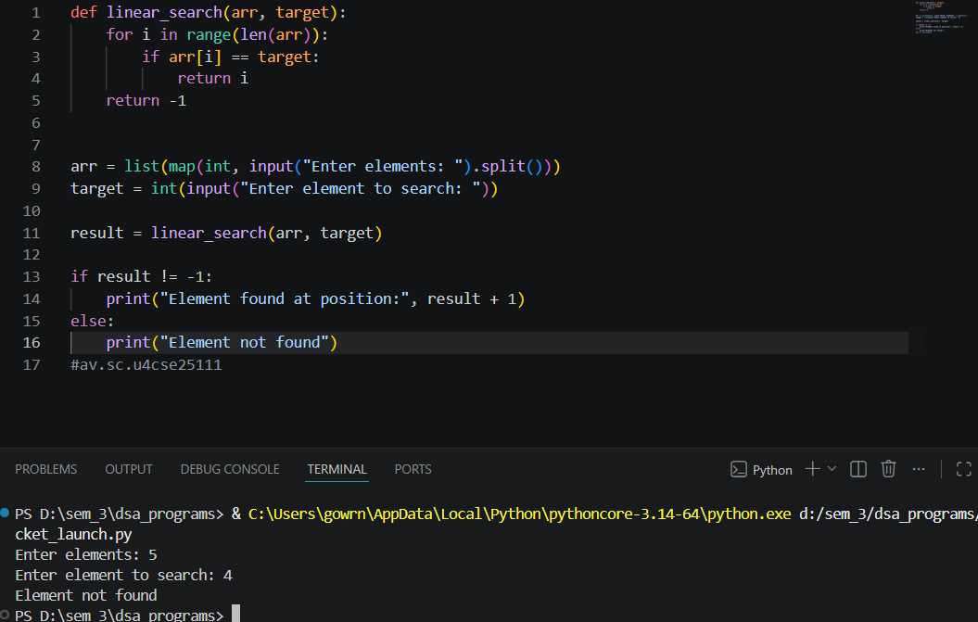

Explanation:
This Python program performs a linear search on a given list. The linear_search() function checks each element of the list one by one from the beginning. If the current element is equal to the target, its position is returned. If all the elements are checked and the target is not found, the function returns -1. The user enters the list elements and the element to search for. For example, if the input is 10 20 30 40 50 and the target is 30, the program displays "Element found at position: 3". Linear search is simple and works by checking elements sequentially.
s.no | Error obtained | Rectification
1. | Return placed in wrong place | Corrected later
2. | Calling the function | Rectified

------------------------------------------------------------------------------------------------

B) Aim: Write a python program to perform binary search on the list.
Program and Output:
Unsorted
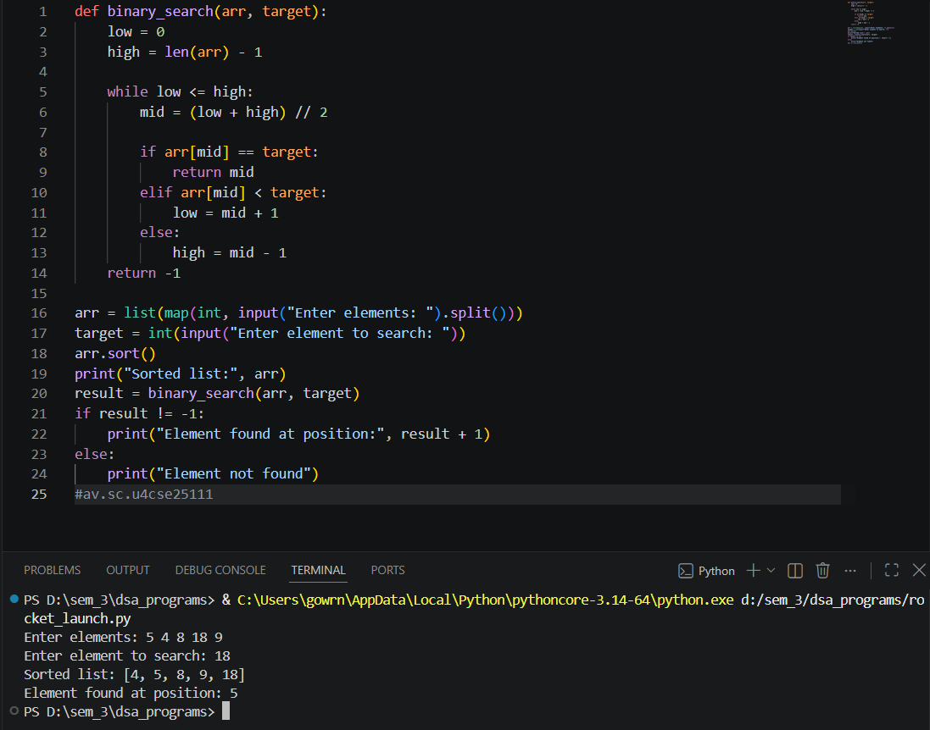
Program and Output:
Sorted
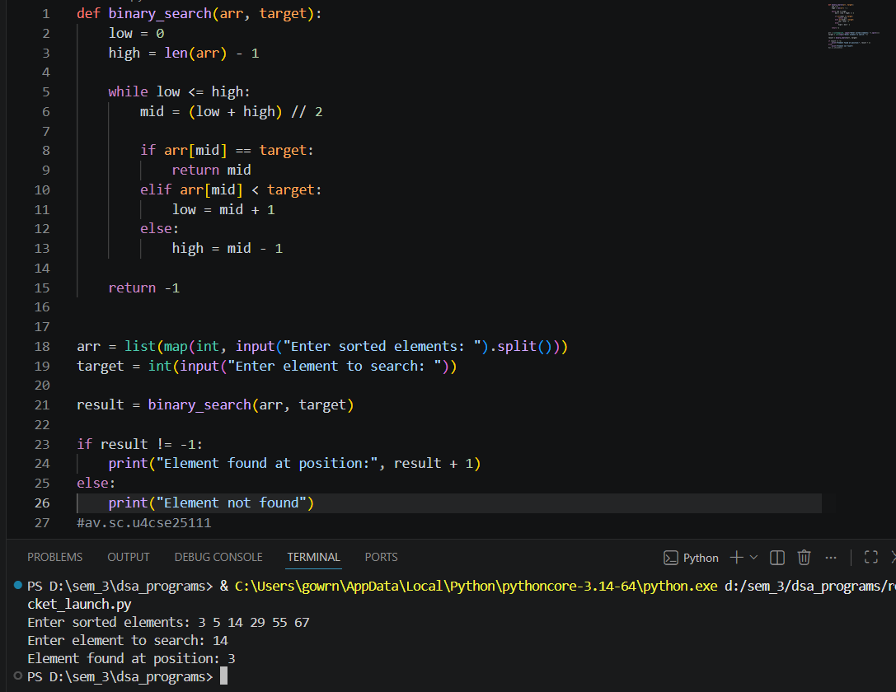

Explanation:
This program performs binary search on a sorted list. The binary_search() function sets low to the first index and high to the last index. It finds the middle element using (low + high) // 2. If the middle element is equal to the target, the position is returned. If the target is greater than the middle element, the search continues in the right half; otherwise, it continues in the left half. This process continues until the element is found or the search range becomes empty.
s.no | Error obtained | Rectification
1. | Mistakes in main logic | Rectified
2. | Errors in conditions | Rectified

--------------------------------------------------------------------------------------------------------------

WEEK-3
- AIM: write a python program to implement bubble sort, where the elements are taken from user.
Program and Output:
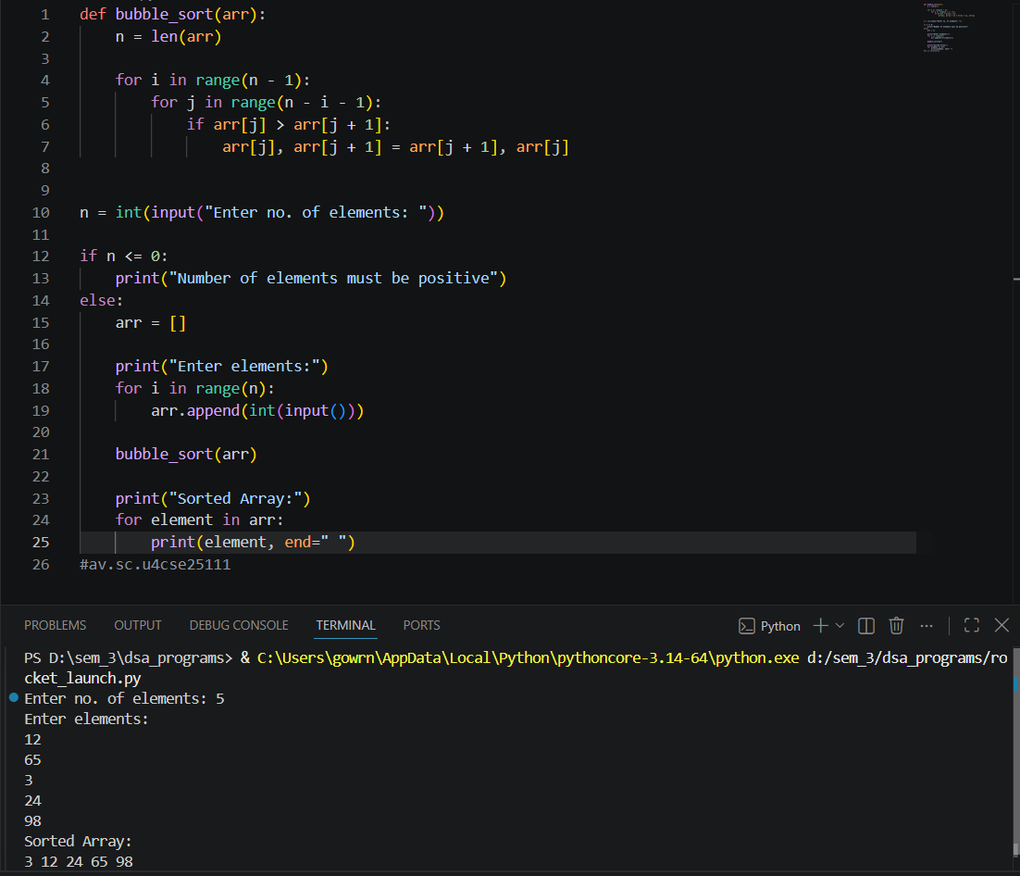
Explanation:
This Python program implements Bubble Sort to arrange the elements in ascending order. First, the program asks the user to enter the number of elements and checks whether the number is positive. An empty list arr is created, and the elements are taken from the user using a for loop and stored using arr.append(). The bubble_sort() function then sorts the list. The outer loop controls the number of passes, while the inner loop compares adjacent elements. If arr[j] is greater than arr[j + 1], the two elements are swapped. After every pass, the largest unsorted element moves to the end of the list. Finally, the sorted elements are displayed. For example, if the input elements are 12, 65, 3, 25, 98, the output will be 3 12 24 65 98 .
s.no | Error obtained | Rectification
1. | Mistakes in main logic | Rectified
2. | Errors in conditions | Rectified
----------------------------------------------------------------------------------------------------------------
- AIM: write a python program to implement insertion sort, where the elements are taken from user.
Program and Output:
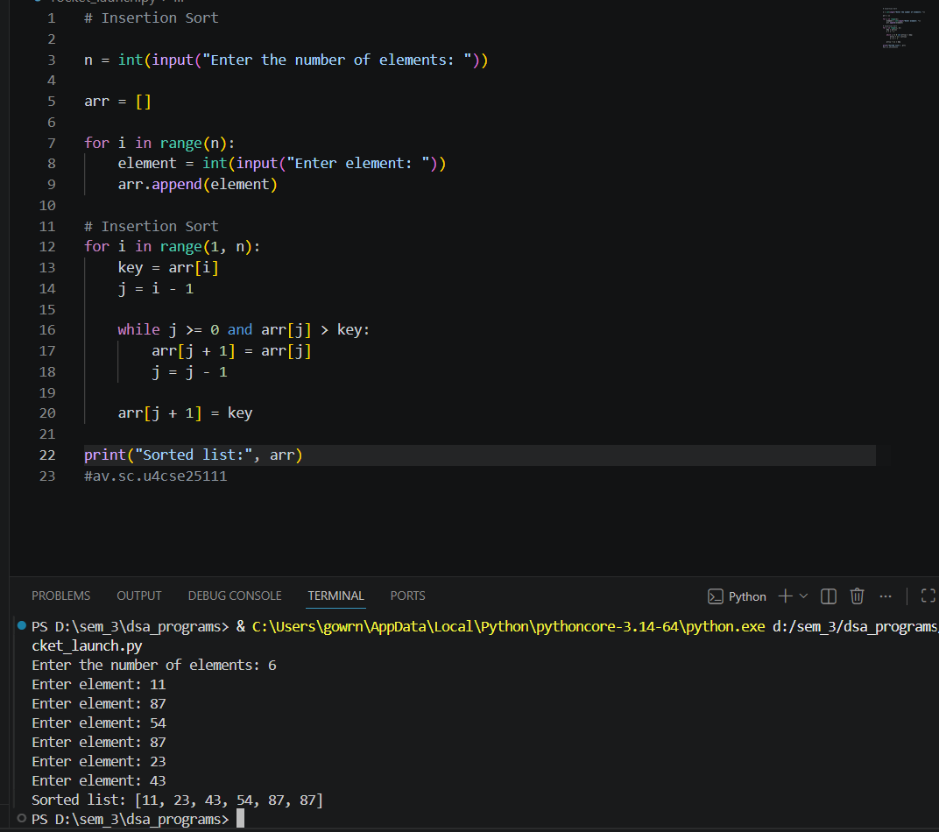
Explanation:
This Python program implements Insertion Sort to arrange the elements in ascending order. First, the program asks the user to enter the number of elements and stores it in n. An empty list arr is created, and the elements are taken from the user using a for loop and stored using arr.append(). The Insertion Sort process then starts from the second element because the first element is considered already sorted. The current element is stored in the variable key, and it is compared with the elements before it. If an element is greater than key, it is moved one position to the right. This process continues until the correct position for key is found, and then key is inserted into that position. After each pass, the sorted portion of the list increases by one element. Finally, the sorted elements are displayed. For example, if the input elements are 11, 87, 54, 87,23,43 the output will be11 23 43 54 87 87.
s.no | Error obtained | Rectification
1. | Mistakes in main logic | Rectified
2. | Errors in conditions | Rectified

----------------------------------------------------------------------------------------------------------------

- AIM: write a python program to implement selection sort, where the elements are taken from user.
Program and Output:
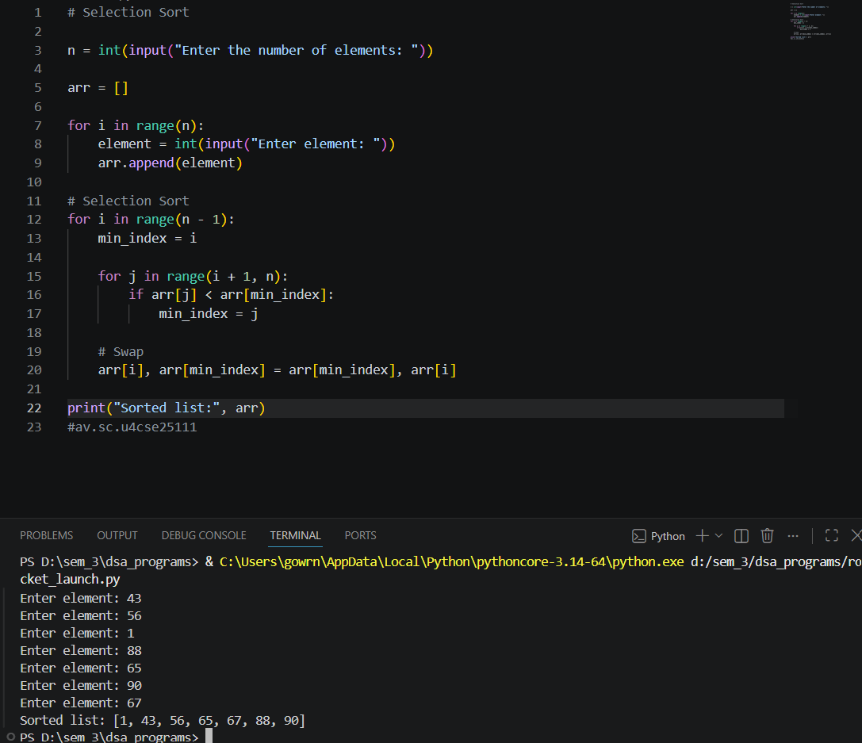
Explanation:
This Python program implements Selection Sort to arrange the elements in ascending order. First, the program asks the user to enter the number of elements and stores it in n. An empty list arr is created, and the elements are taken from the user using a for loop and stored using arr.append(). The Selection Sort process then divides the list into a sorted part and an unsorted part. The outer loop selects the position where the next smallest element should be placed. The variable min_index stores the index of the smallest element found in the unsorted part. The inner loop compares the remaining elements with the current minimum element. If a smaller element is found, min_index is updated. After each pass, the smallest element from the unsorted part is swapped with the element at the current position. This process continues until all elements are sorted. Finally, the sorted elements are displayed. For example, if the input elements are 43,56,1,88,65,90,67 the output will be 1 , 43, 56 , 65 , 67, 88,90.
s.no | Error obtained | Rectification
1. | Mistakes in main logic | Rectified
2. | Errors in conditions | Rectified

----------------------------------------------------------------------------------------------------------------

WEEK-4
- AIM: write a python program to implement merge sort, where the elements are taken from user.
Program:
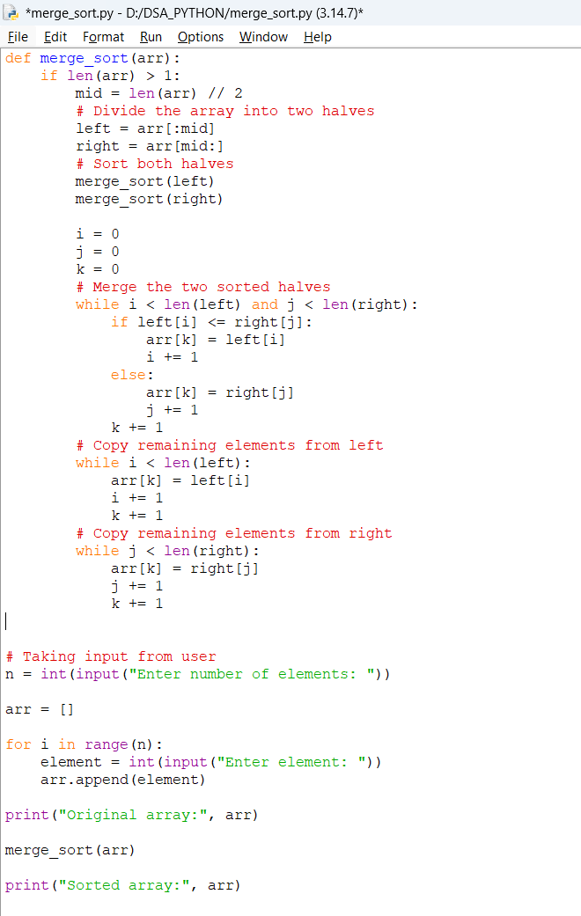
Output:
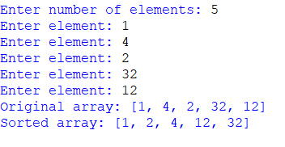
Explanation:
This Python program implements Merge Sort to arrange the elements in ascending order. First, the program asks the user to enter the number of elements and stores it in n. An empty list arr is created, and the elements are taken from the user using a for loop and stored using arr.append(). The Merge Sort process follows the divide-and-conquer technique. The merge_sort() function first checks the base condition using if len(arr) <= 1, because a list containing one or zero elements is already sorted. The list is then divided into two halves using mid = len(arr) // 2. The left and right variables store the two halves of the array. The function is called recursively for both halves until the array is divided into individual elements. After that, the two sorted halves are merged by comparing their elements. The variables i, j, and k are used to keep track of the positions in the left array, right array, and original array respectively. The smaller element is copied into the original array. Finally, any remaining elements from the left or right array are copied. This process continues until the complete array is sorted. For example, if the input elements are 10, 2, 11, 8, 16, the output will be 2, 8, 10, 11, 16.
s.no | Error obtained | Rectification
1. | Mistakes in main logic | Rectified
2. | Errors in conditions | Rectified

------------------------------------------------------------------------------------------------
- AIM: write a python program to implement Quick sort, where the elements are taken from user.
Program:
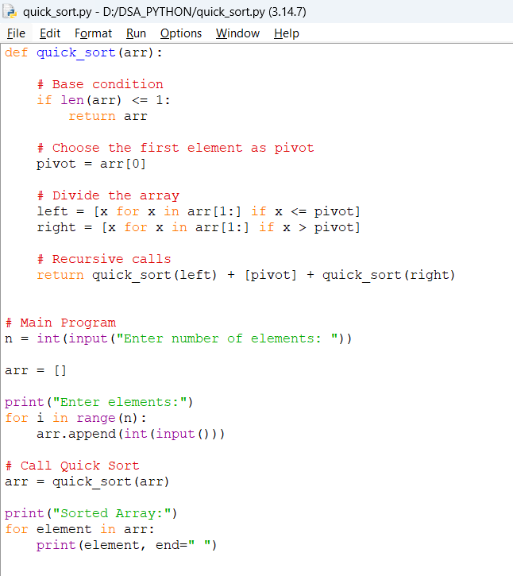
Output:
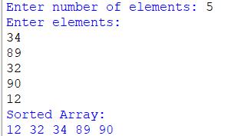

Explanation:
This Python program implements Quick Sort to arrange the elements in ascending order. First, the program asks the user to enter the number of elements and stores it in n. An empty list arr is created, and the elements are taken from the user using a for loop and stored using arr.append(). The Quick Sort process uses the divide-and-conquer technique. The quick_sort() function first checks the base condition using if len(arr) <= 1, because an array with one or zero elements is already sorted. The first element is selected as the pivot. The remaining elements are divided into two lists: left contains elements smaller than or equal to the pivot, while right contains elements greater than the pivot. The quick_sort() function is then recursively called for both left and right. Finally, the sorted left part, pivot, and sorted right part are combined to produce the sorted array.
s.no | Error obtained | Rectification
1. | Mistakes in main logic | Rectified
2. | Errors in conditions | Rectified

------------------------------------------------------------------------------------------------

WEEK-5
- AIM: Write a program to implement SLL with the below operations. Create linked list, Insert Beginning, Insert End, Insert at Index, delete by value, delete first node, delete last node, count number of nodes, display/transverse exit.
Program:
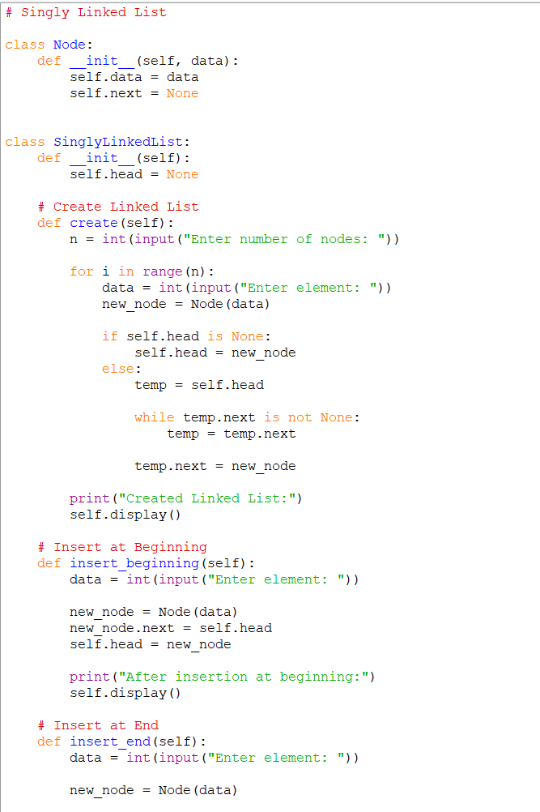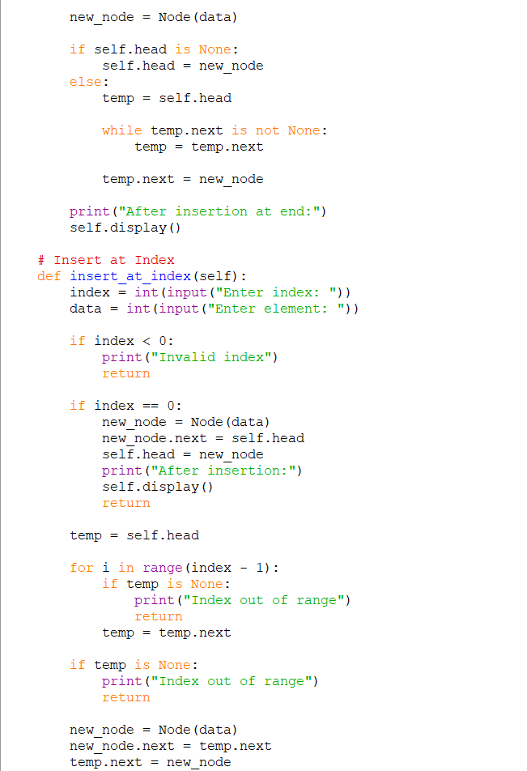
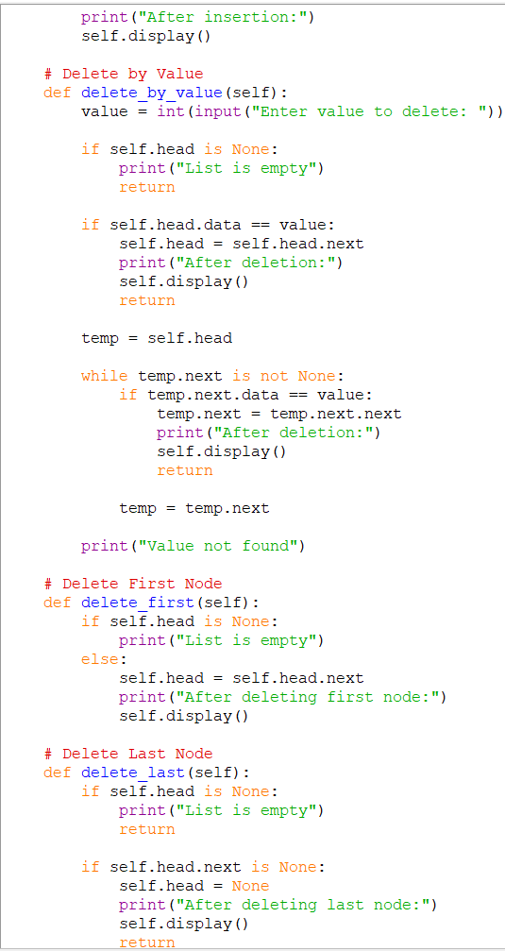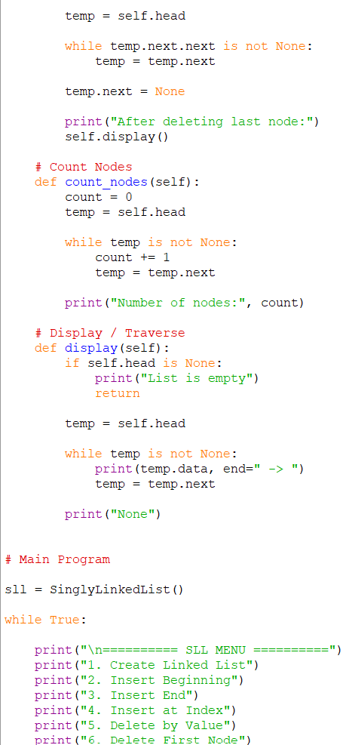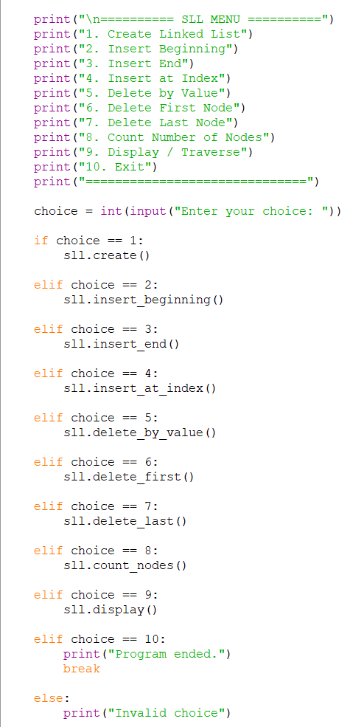

Output:
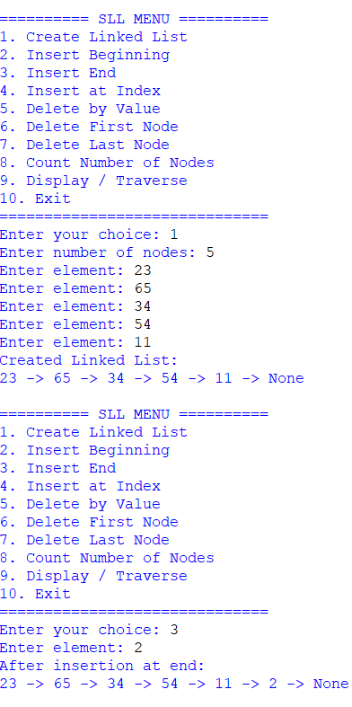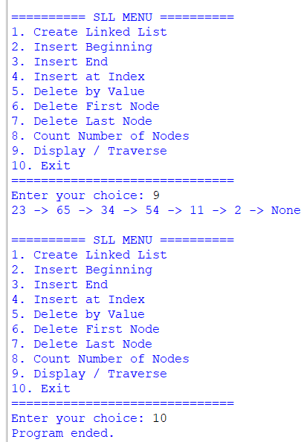
Explanation:
This Python program implements a Singly Linked List (SLL) with operations such as creating a linked list, inserting nodes at the beginning, end, and a specific index, deleting a node by value, deleting the first and last nodes, counting the number of nodes, and displaying the list. The Node class represents each node and contains two parts: data and next, where data stores the value and next points to the next node. The SinglyLinkedList class uses the head pointer to point to the first node. During creation, each new node is connected to the previous node using the next pointer. For insertion, a new node is created and the required links are updated. For deletion, the next pointers are changed to remove the required node from the list. The count operation traverses the complete list and counts the nodes, while the display operation traverses from the head and prints the elements using ->. The program uses a menu-driven approach, allowing the user to perform different operations repeatedly until the Exit option is selected. For example, if the elements are 10, 20, 30, 40, the output will be 10 -> 20 -> 30 -> 40 -> None.
s.no | Error obtained | Rectification
1. | Mistakes in main logic | Rectified
2. | Errors in conditions | Rectified
3. | Errors in node linking | Rectified
4. | Errors in insertion and deletion | Rectified
5. |  | Rectified
  Errors in index handling
----------------------------------------------------------------------------------------------------------------
B)AIM: Write a program to implement DLL with the below operations. Create linked list, Insert Beginning, Insert End, Insert at Index, delete by value, delete first node, delete last node, count number of nodes, display/transverse exit.
Program:
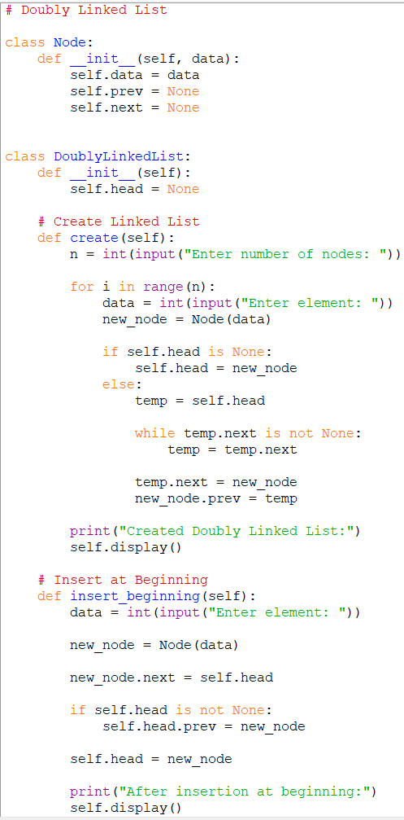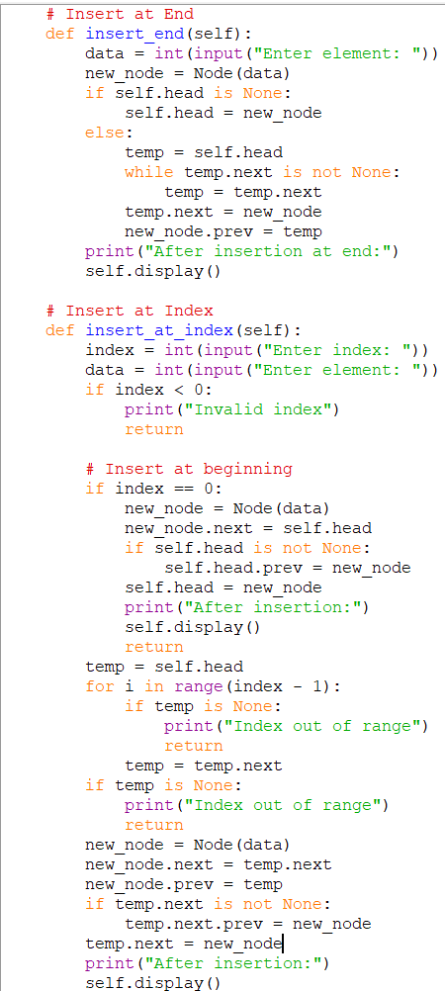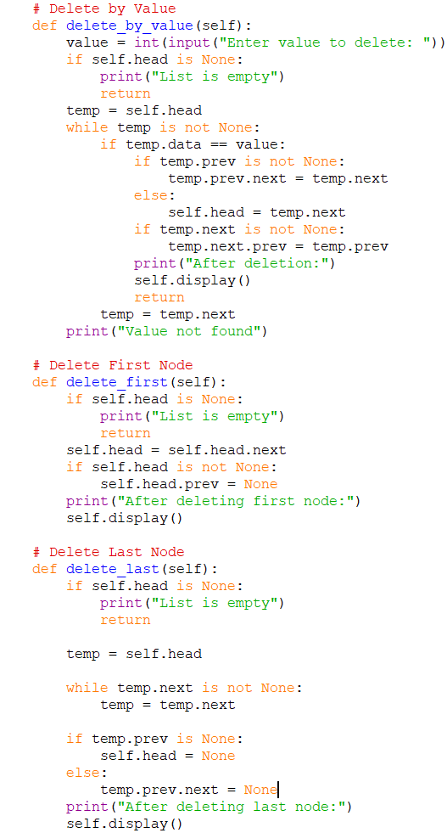

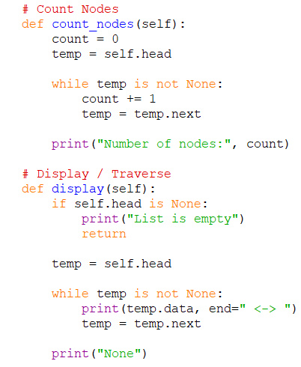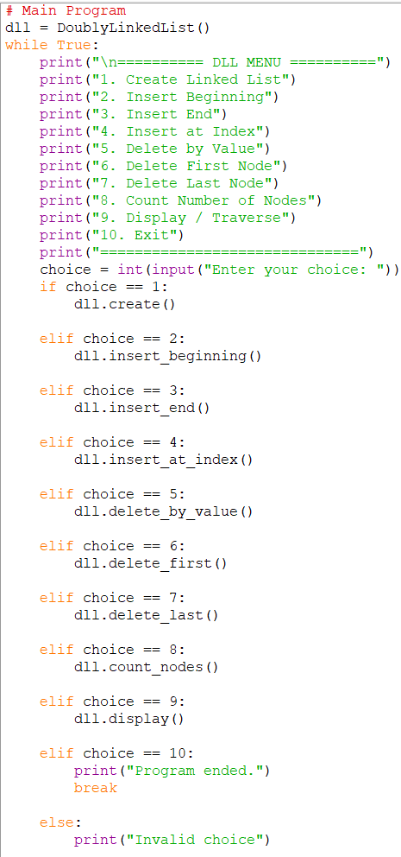
Output:
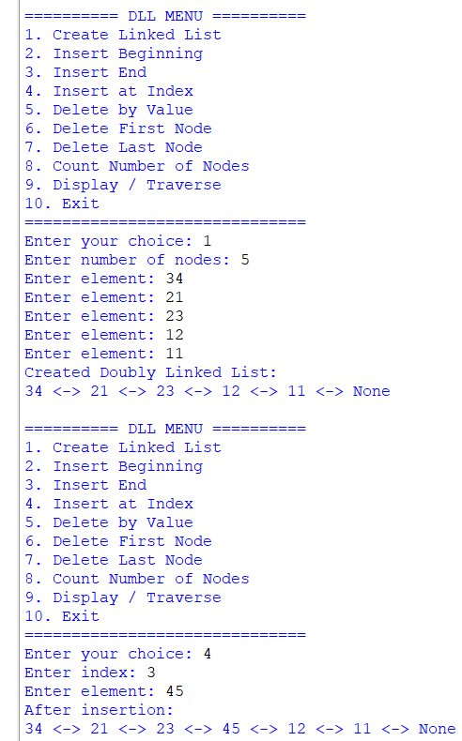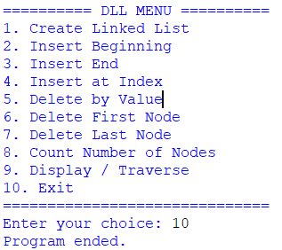
Explanation:
This Python program implements a Doubly Linked List (DLL) with operations such as creating a linked list, inserting nodes at the beginning, end, and a specific index, deleting a node by value, deleting the first and last nodes, counting the number of nodes, and displaying the list. The Node class represents each node and contains three parts: data, prev, and next, where prev points to the previous node and next points to the next node. The DoublyLinkedList class uses the head pointer to point to the first node. During creation, nodes are connected using both prev and next pointers. For insertion, a new node is created and the required links are updated. For deletion, the appropriate prev and next links are changed to remove the node from the list. The count operation traverses the list and counts the nodes, while the display operation traverses from the head and prints the elements using <->. The program uses a menu-driven approach, allowing the user to perform different operations repeatedly until the Exit option is selected. For example, if the elements are 10, 20, 30, 40, the output will be 10 <-> 20 <-> 30 <-> 40 <-> None.
s.no | Error obtained | Rectification
1. | Mistakes in main logic | Rectified
2. | Errors in conditions | Rectified
3. | Errors in previous and next linking | Rectified
4. | Errors in insertion and deletion | Rectified
5. |  | Rectified
  Errors in index handling
----------------------------------------------------------------------------------------------------------------

WEEK-6
A) AIM: Write a python program to implement stack operations such as push, pop, peek, display using an array and a linked list.
Program using Array:
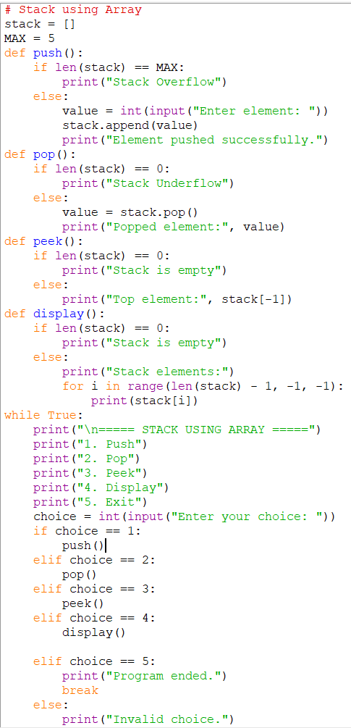
Output:
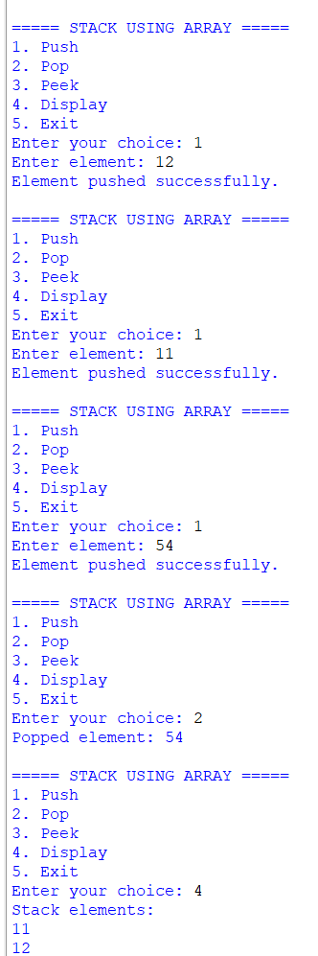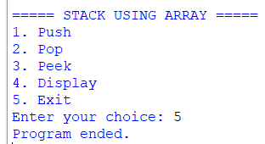
Explanation:
This Python program implements a Stack using an array (list) and performs the operations Push, Pop, Peek, and Display. The stack follows the LIFO (Last In, First Out) principle, where the last inserted element is removed first. An empty list called stack is used to store the elements and MAX defines the maximum stack size. The Push operation adds a new element using append() and checks for stack overflow. The Pop operation removes the top element using pop() and checks for stack underflow. The Peek operation displays the top element without removing it using stack[-1]. The Display operation prints all elements starting from the top. The program uses a menu-driven approach, allowing the user to repeatedly perform stack operations until the Exit option is selected.
Program using Linkedlist:
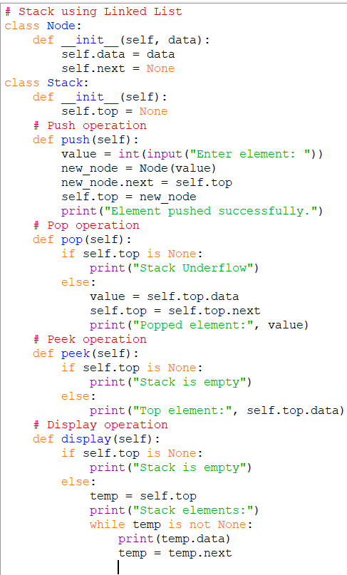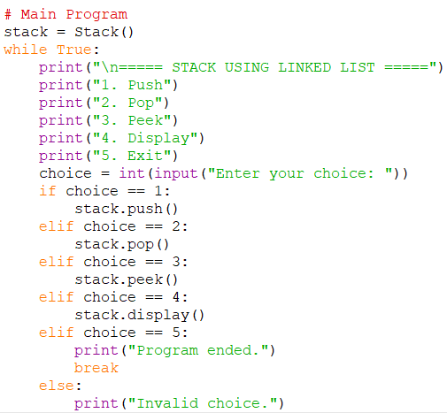

Output:
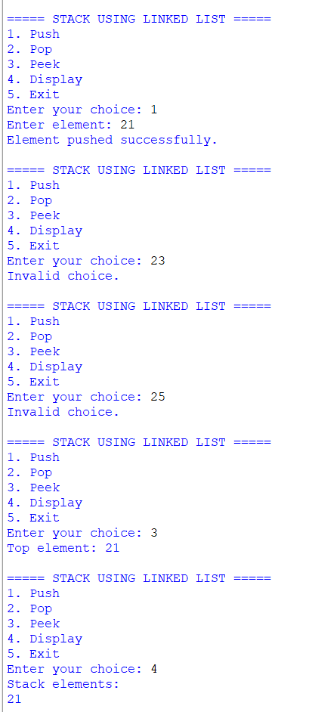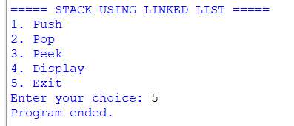
Explanation:
This Python program implements a Stack using a Linked List and performs the operations Push, Pop, Peek, and Display. The stack follows the LIFO (Last In, First Out) principle. The Node class represents each node and contains data and next, while the Stack class uses the top pointer to point to the top node. The Push operation creates a new node and places it at the top of the stack. The Pop operation removes the top node and moves the top pointer to the next node. The Peek operation displays the data of the top node without removing it. The Display operation traverses the linked list from the top and prints all elements. The program uses a menu-driven approach, allowing the user to perform different stack operations repeatedly until the Exit option is selected.
Error Table:
s.no | Error obtained | Rectification
1. | Mistakes in main logic | Rectified
2. | Errors in conditions | Rectified
3. | Errors in push and pop operations | Rectified
4. | Errors in top pointer handling | Rectified
5. |  | Rectified
  Errors in display operation
----------------------------------------------------------------------------------------------------------------

WEEK-7
A)AIM: Write a python program to implement Queue and its operations such as enqueue ,dequeue, peek, display with a menu driven approach. Implement using array and linked list data structures
Program using array:
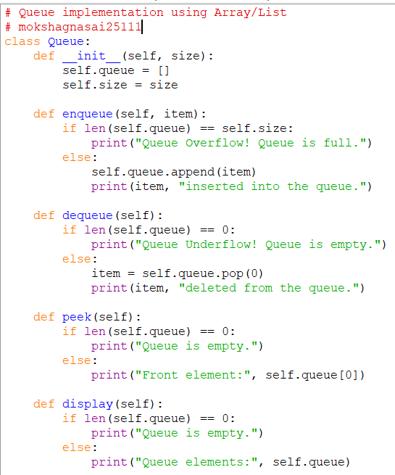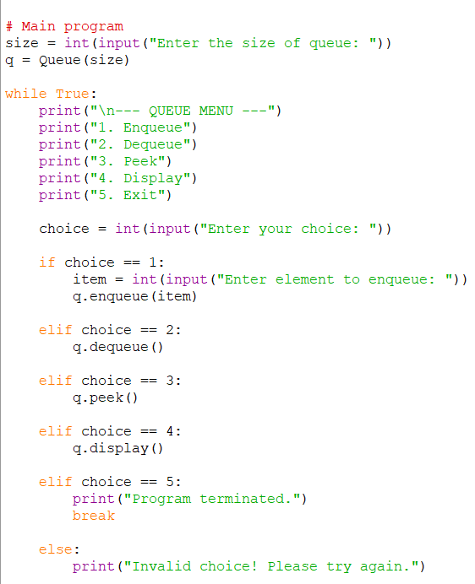
Output:
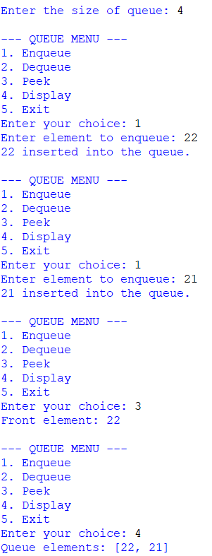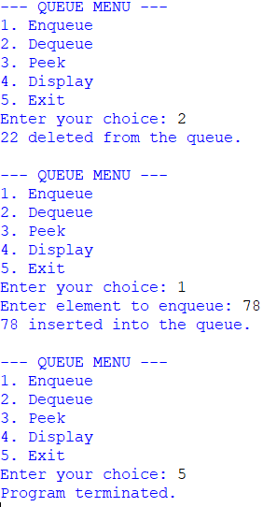
Explanation:
This Python program implements a Queue using an Array/List and performs the operations Enqueue, Dequeue, Peek, and Display. The queue follows the FIFO (First In, First Out) principle, where the first element inserted is the first element removed. The Queue class contains a list called queue to store the elements and a size variable to define the maximum capacity of the queue. The Enqueue operation adds an element at the rear using append() and checks whether the queue is full; if it is full, Queue Overflow is displayed. The Dequeue operation removes the first element using pop(0) and checks whether the queue is empty; if it is empty, Queue Underflow is displayed. The Peek operation displays the front element without removing it, while the Display operation shows all the elements currently present in the queue. The program uses a menu-driven approach, allowing the user to repeatedly perform queue operations until the Exit option is selected.
Error Table:
s.no | Error obtained | Rectification
1. | Mistakes in main logic | Rectified
2. | Errors in conditions | Rectified
3. | Errors in enqueue and dequeue operations | Rectified
4. | Errors in front element handling | Rectified
5. |  | Rectified
  Errors in display operation
----------------------------------------------------------------------------------------------------------------

Program using linked list:
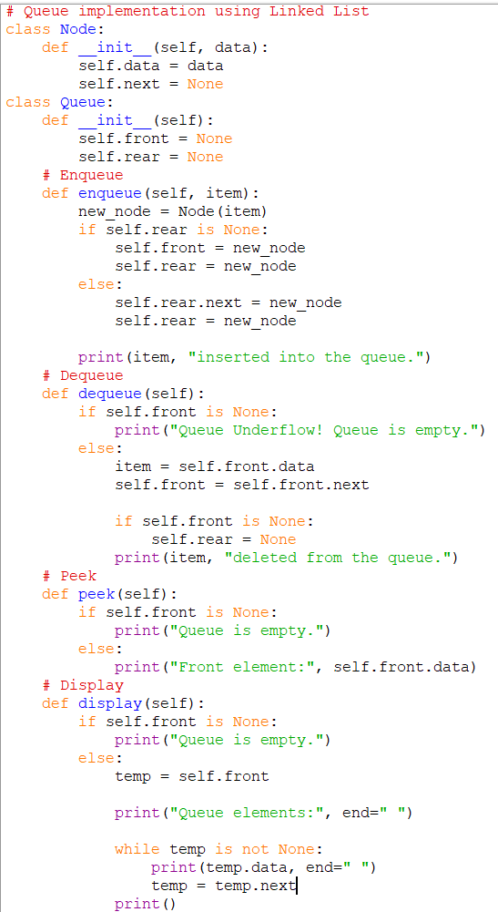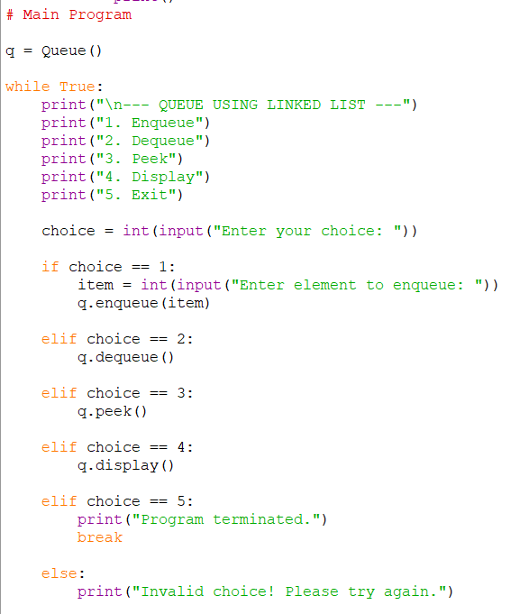
Output:
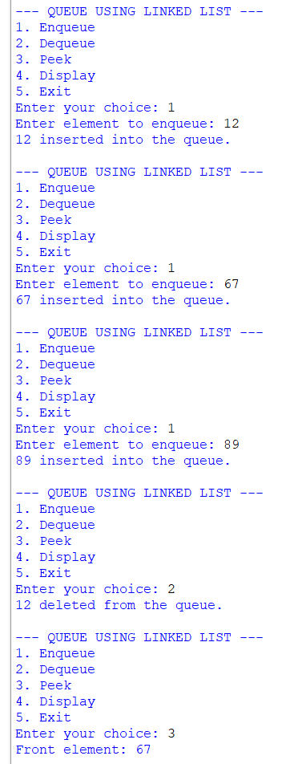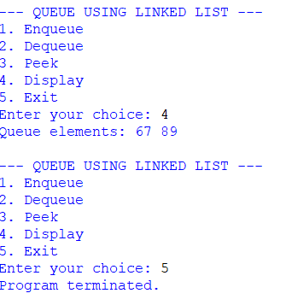
Explanation:
This Python program implements a Queue using a Linked List and performs the operations Enqueue, Dequeue, Peek, and Display. The queue follows the FIFO (First In, First Out) principle, where the first element inserted is the first element removed. The Node class represents each node and contains data and next, while the Queue class uses two pointers, front and rear, to maintain the queue. The Enqueue operation creates a new node and adds it at the rear of the queue. The Dequeue operation removes the node from the front and moves the front pointer to the next node. If the queue becomes empty after deletion, the rear pointer is also set to None. The Peek operation displays the front element without removing it, while the Display operation traverses the linked list from front to rear and displays all elements. The program uses a menu-driven approach, allowing the user to perform different queue operations repeatedly until the Exit option is selected.
Error Table:
s.no | Error obtained | Rectification
1. | Mistakes in main logic | Rectified
2. | Errors in conditions | Rectified
3. | Errors in enqueue and dequeue operations | Rectified
4. | Errors in front and rear pointer handling | Rectified
5. |  | Rectified
  Errors in display operation
----------------------------------------------------------------------------------------------------------------

B)AIM : Write a python program to implement Circular Queue and its operations such as enqueue , dequeue, peek, display with a menu driven approach. Implement using array and linked list data structures
Program using array and Output:
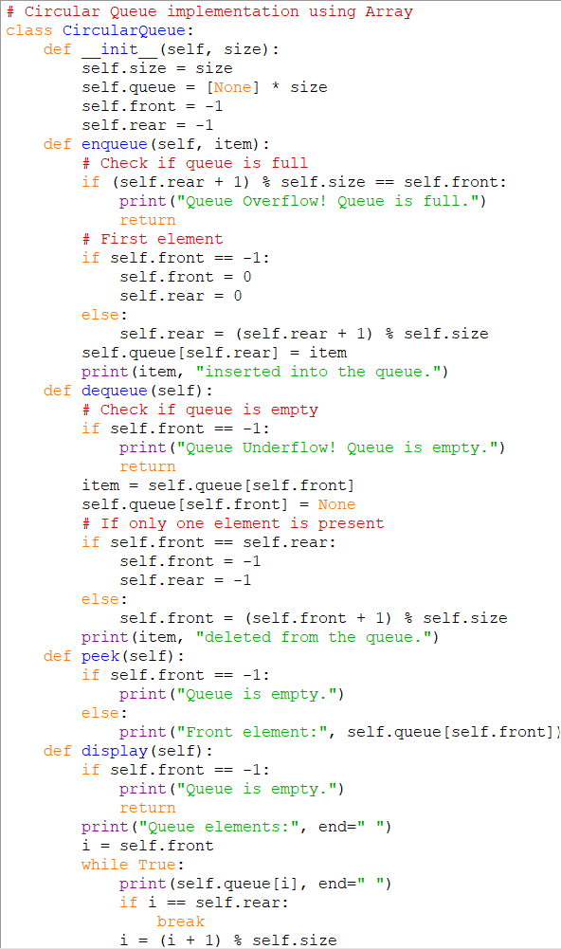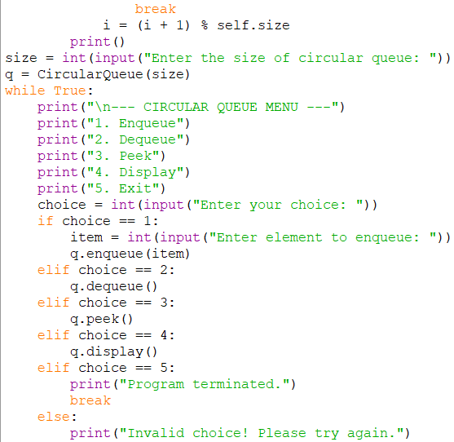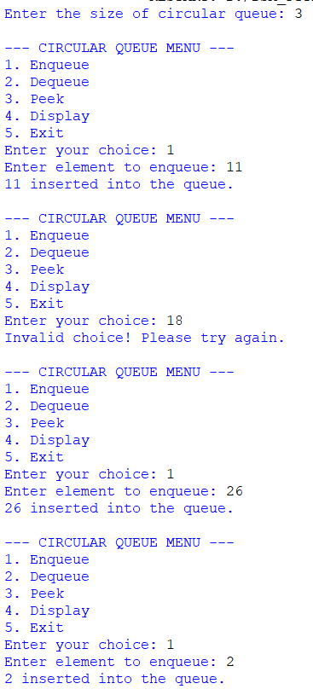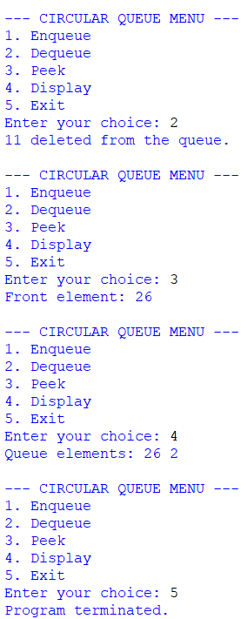
Explanation:
This Python program implements a Circular Queue using an Array following the FIFO principle. The queue uses front and rear pointers to keep track of the first and last elements. The enqueue() operation inserts an element at the rear, while dequeue() removes an element from the front. The % operator is used to move the front and rear circularly so that empty positions can be reused. The peek() operation displays the front element without deleting it, and display() shows all the elements in the circular queue. The program also checks for Queue Overflow when the queue is full and Queue Underflow when the queue is empty. A menu-driven approach is used to perform all the queue operations repeatedly.
Error Table:
s.no | Error obtained | Rectification
1. | Mistakes in main logic | Rectified
2. | Errors in conditions | Rectified
3. | Errors in enqueue and dequeue operations | Rectified
4. | Errors in front and rear handling | Rectified
5. |  | Rectified
  Errors in circular movement
----------------------------------------------------------------------------------------------------------------
Program using linked list and Output:
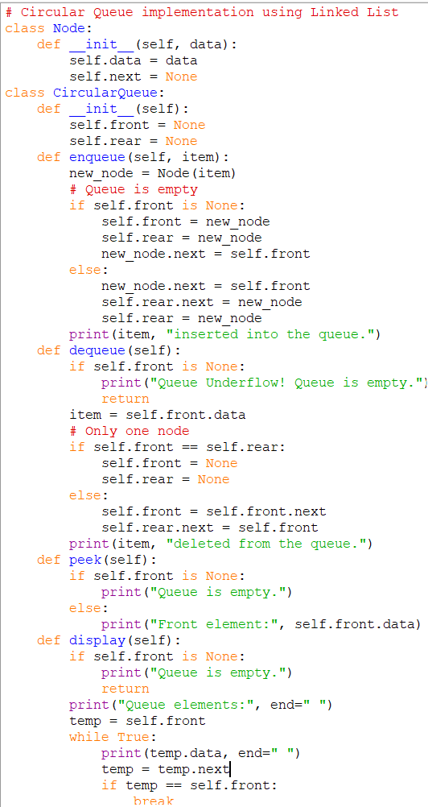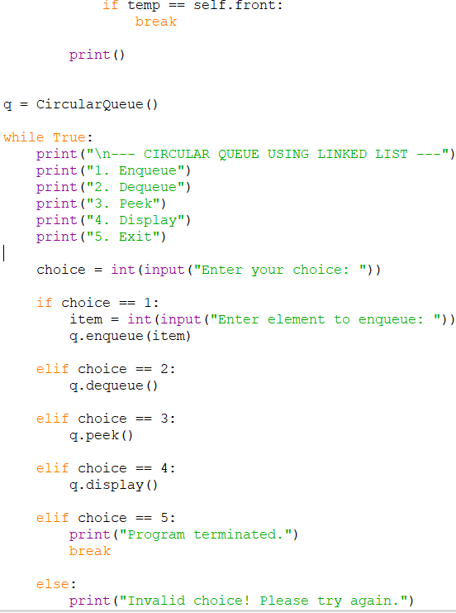
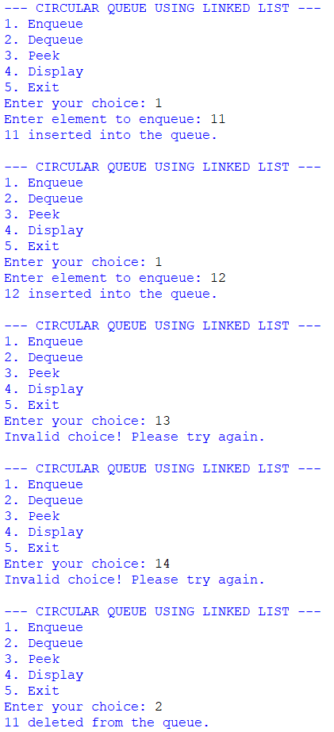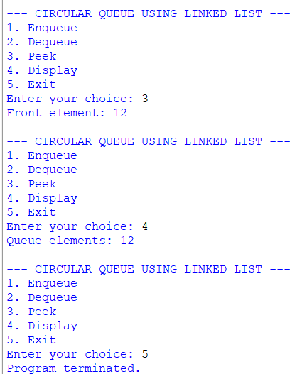
Explanation:
This Python program implements a Circular Queue using a Linked List following the FIFO principle. Each node contains data and a next pointer. The queue uses front and rear pointers, and the next pointer of the rear node always points back to the front node, making the queue circular. The enqueue() operation inserts a new node at the rear, while dequeue() removes the node from the front. The peek() operation displays the front element without deleting it, and display() traverses the circular linked list until it reaches the front node again. A menu-driven approach is used to perform enqueue, dequeue, peek, and display operations.
Error Table:
s.no | Error obtained | Rectification
1. | Mistakes in main logic | Rectified
2. | Errors in conditions | Rectified
3. | Errors in enqueue and dequeue operations | Rectified
4. | Errors in front and rear handling | Rectified
5. |  | Rectified
  Errors in circular movement
----------------------------------------------------------------------------------------------------------------

WEEK-8
A)AIM: write a python program to implement a binary tree with its operations using a array and a linked list.
Program using array:
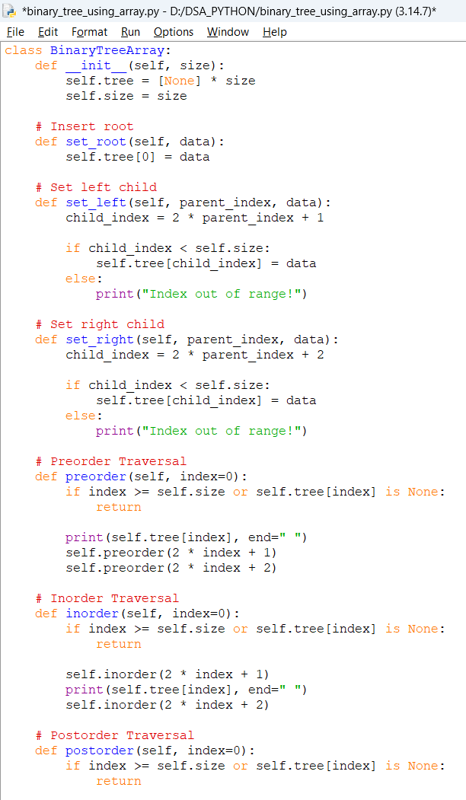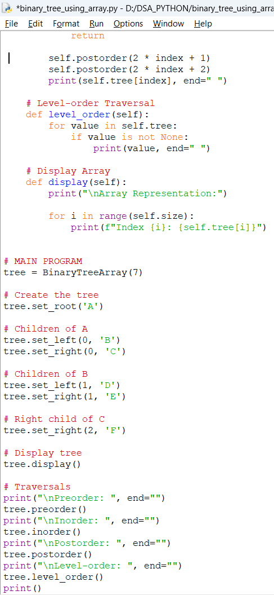
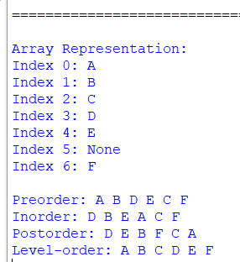
Explanation:
This Python program implements a Binary Tree using an Array. The BinaryTreeArray class initializes an array of a specified size to store the tree elements. The set_root() method inserts the root node, while set_left() and set_right() insert the left and right children of a given parent node using the formulas 2 * parent_index + 1 and 2 * parent_index + 2, respectively. The preorder() traversal visits the root, left subtree, and right subtree; inorder() visits the left subtree, root, and right subtree; and postorder() visits the left subtree, right subtree, and root. The level_order() method displays the elements level by level by traversing the array, and the display() method prints each array index and its corresponding value. The program creates a binary tree with nodes A, B, C, D, E, and F and displays the tree along with its four traversals.Error Table:
s.no | Error obtained | Rectification
1. | Missing statement inside if in set_right() | Rectified
2. | Syntax error due to incomplete if block | Rectified
----------------------------------------------------------------------------------------------------------------
Program using linked list and Output:
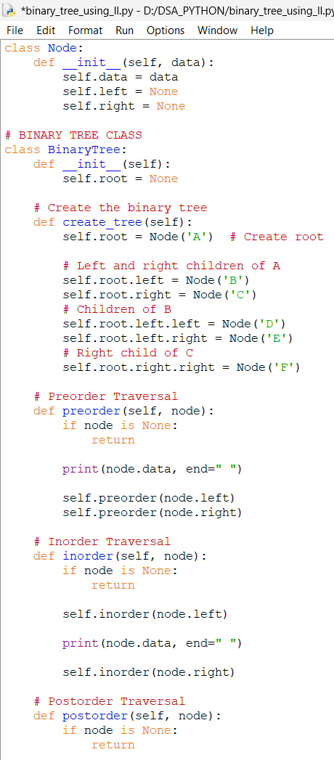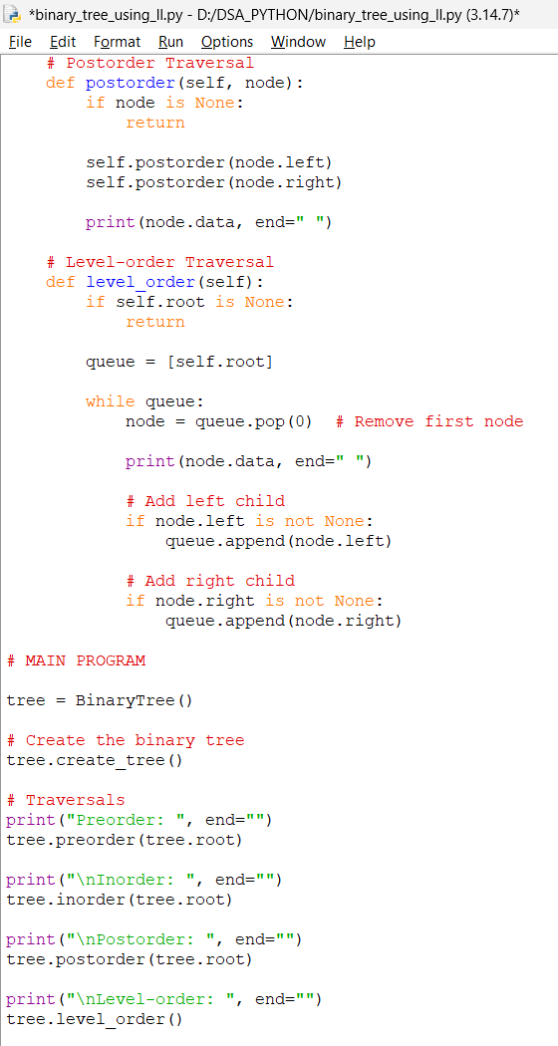
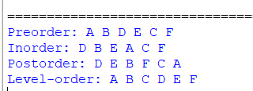
Explanation:
This Python program implements a Binary Tree using a Linked List. The Node class represents each node and contains three attributes: data, left, and right, where data stores the value, left points to the left child, and right points to the right child. The BinaryTree class uses the root pointer to identify the root node. The create_tree() method creates the binary tree with nodes A, B, C, D, E, and F by connecting the nodes through their left and right pointers. The preorder() traversal visits the root, left subtree, and right subtree; inorder() visits the left subtree, root, and right subtree; and postorder() visits the left subtree, right subtree, and root. The level_order() traversal uses a queue to visit nodes level by level, adding the left and right children of each node to the queue. Finally, the program displays all four traversals of the binary tree.
Error Table:
s.no | Error obtained | Rectification
1. | Mistakes in main logic | Rectified
2. | Errors in traversal methods | Rectified
3. | Errors in node connections | Rectified
----------------------------------------------------------------------------------------------------------------

WEEK-9
A)AIM: write a python program to implement a binary search treee with its operation and traversals.
CODE AND OUTPYT:
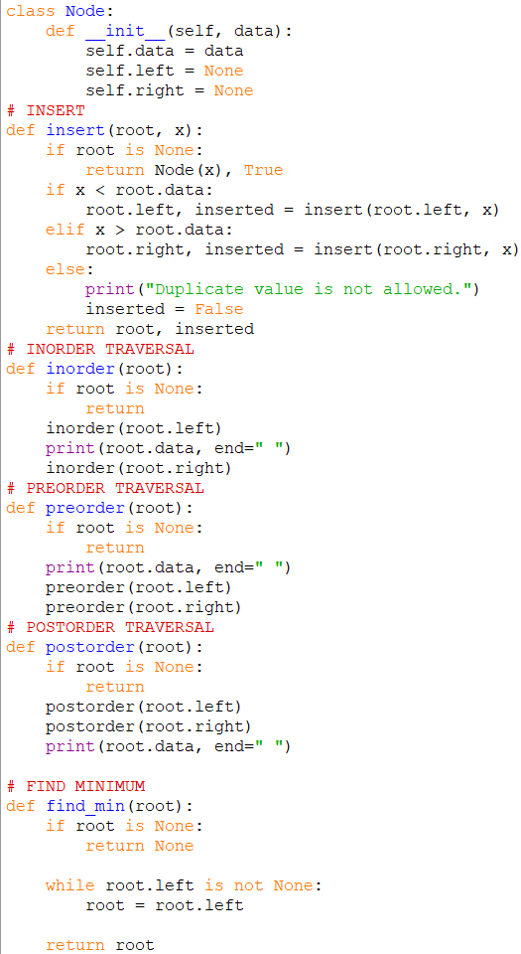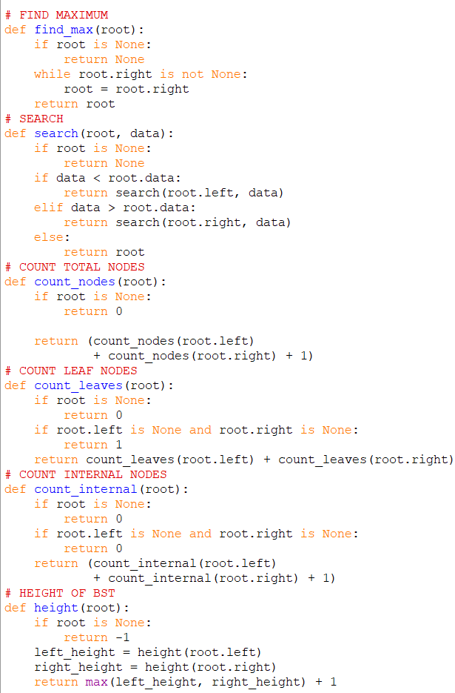

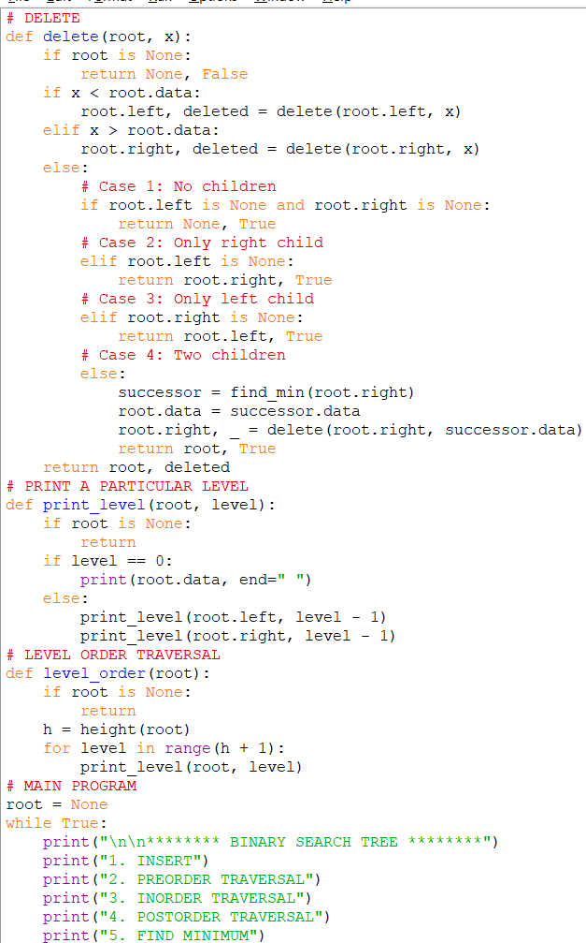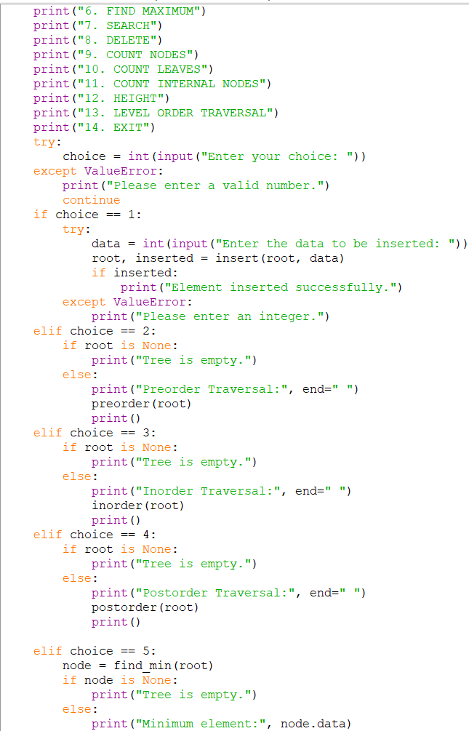
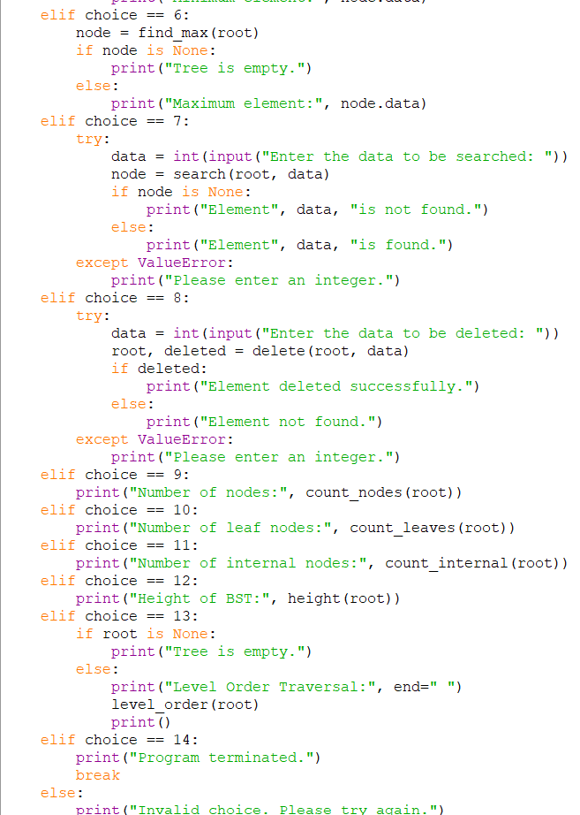
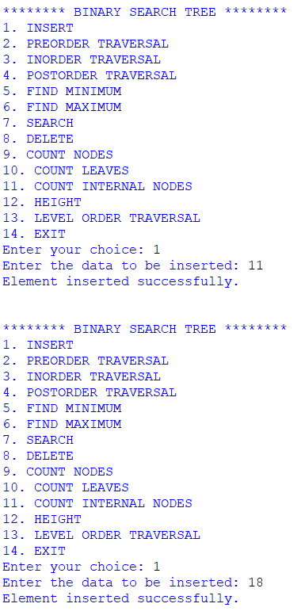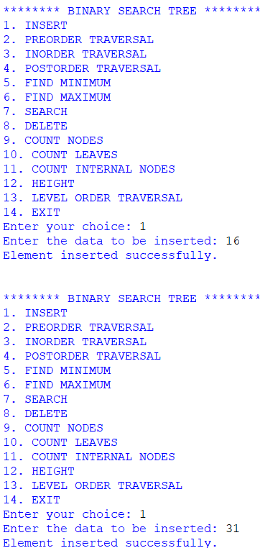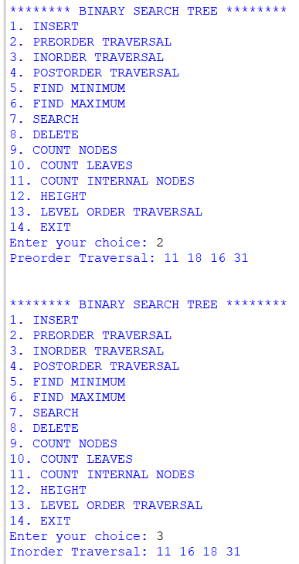
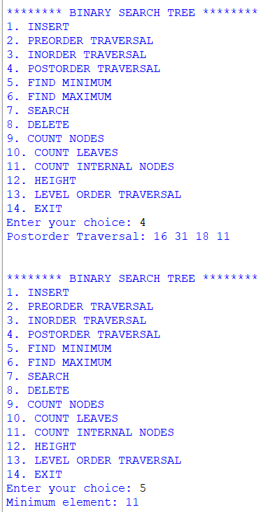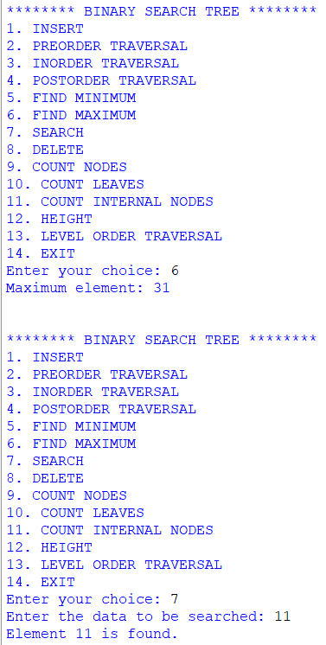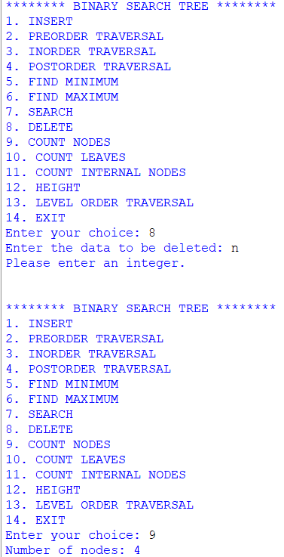

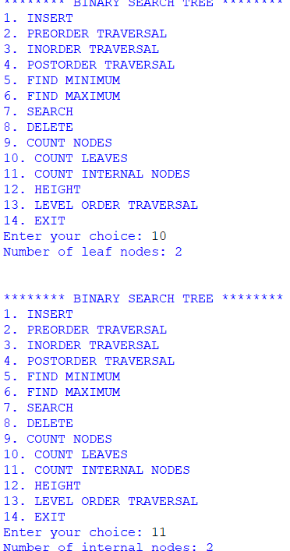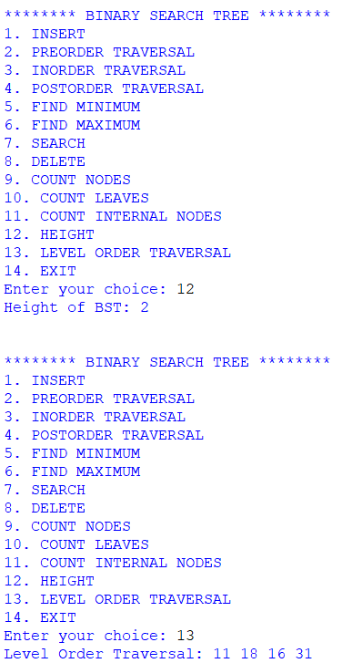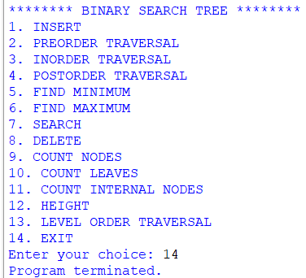
Explanation:
This Python program implements a Binary Search Tree (BST) with operations such as insertion, deletion, searching, traversals, finding minimum and maximum values, counting nodes, counting leaf nodes, counting internal nodes, finding the height, and level-order traversal. The Node class represents each node with data, left, and right pointers. The insert() function inserts elements according to the BST property: smaller values go to the left subtree, and larger values go to the right subtree; duplicate values are not allowed. The search() function searches for a given element, while find_min() and find_max() find the minimum and maximum values. The delete() function removes a node by handling three cases: a node with no children, a node with one child, and a node with two children. The inorder(), preorder(), and postorder() functions perform tree traversals in different orders. The count_nodes(), count_leaves(), and count_internal() functions calculate the total number of nodes, leaf nodes, and internal nodes, respectively. The height() function calculates the height of the BST, and level_order() displays the nodes level by level. Finally, a menu-driven approach allows the user to perform these operations repeatedly until the Exit option is selected.
Error Table:
s.no | Error obtained | Rectification
1. | Mistakes in main logic | Rectified
2. | Errors in traversal methods | Rectified
3. | Errors in insertion and deletion | Rectified
4. | Errors in node counting and height calculation | Rectified
----------------------------------------------------------------------------------------------------------------

